can you please explain the above 10 by using house analagy
Great question — using a house analogy makes OWASP very easy to remember. Let’s imagine your web application = your house 🏠, and each vulnerability is a different security mistake.

🏠 OWASP Top 10 — Explained Using House Analogy

1. 🧨 Broken Access Control
House Problem:
Anyone can enter any room in your house — even your locker or bedroom.
Example:
A guest walks straight into your personal safe room.
👉 In App: Users can access admin pages or other users' data.
👉 Fix: Lock rooms properly → role-based access (admin/user).

2. 🔑 Cryptographic Failures
House Problem:
You keep your valuables (cash, gold) openly on the table instead of locking them.
Example:
Passwords written on paper stuck to the wall.
👉 In App: Sensitive data stored without encryption.
👉 Fix: Put valuables in a locker → encryption & hashing.

3. 💉 Injection
House Problem:
You allow strangers to give instructions to your house helper — and the helper blindly follows.
Example:
Stranger says: “Open all doors and give me everything” → helper obeys.
👉 In App: User input runs as commands (SQL Injection).
👉 Fix: Verify instructions → use prepared statements.

4. 🧠 Insecure Design
House Problem:
Your house is poorly designed — no fence, no gate, no security plan.
Example:
Main door opens directly into your valuables room.
👉 In App: Security not considered during design.
👉 Fix: Plan security from beginning (like adding CCTV, gates).

5. ⚙️ Security Misconfiguration
House Problem:
You installed locks but forgot to use them or configured them wrongly.
Example:
- Door lock exists but always kept open
- Security camera is turned OFF
👉 In App: Debug mode ON, default passwords.
👉 Fix: Proper setup and configuration.

6. 📦 Vulnerable and Outdated Components
House Problem:
Your locks are old and easy to break.
Example:
Using a 20-year-old lock that thieves already know how to open.
👉 In App: Old libraries (e.g., outdated Spring/Log4j).
👉 Fix: Replace with modern locks → update dependencies.

7. 🔐 Identification & Authentication Failures
House Problem:
Your house doesn’t properly verify who is entering.
Example:
- Anyone who says “I am your friend” is allowed
- No ID check
👉 In App: Weak login system.
👉 Fix: Strong passwords, OTP, MFA.

8. 🧾 Software and Data Integrity Failures
House Problem:
You allow unknown people to install things in your house.
Example:
A stranger installs a fake security system that secretly steals data.
👉 In App: Untrusted code/plugins.
👉 Fix: Only trusted sources, verify integrity.

9. 📊 Security Logging & Monitoring Failures
House Problem:
No one notices if someone breaks into your house.
Example:
- No CCTV
- No alarm
- No record of who entered
👉 In App: No logs or alerts.
👉 Fix: Monitoring systems, alerts.

10. 🌐 Server-Side Request Forgery (SSRF)
House Problem:
You allow outsiders to send instructions to your house to fetch things from inside.
Example:
A stranger says:
👉 “Go to your locker and bring documents” — and your helper does it!
👉 In App: Server makes internal requests on behalf of attacker.
👉 Fix: Restrict what requests can be made.

🧠 Easy Way to Remember
Category | House Meaning
Access Control | Who can enter which room
Cryptography | How valuables are stored
Injection | Blindly following outsider instructions
Design | How secure the house is built
Misconfiguration | Mistakes in setup
Outdated Components | Old locks
Authentication | Verifying identity
Integrity | Trusting installations
Logging | Watching what happens
SSRF | Being tricked to fetch things

🚀 Pro Tip (Interview Ready)
If asked in interview:
👉 “Explain OWASP using analogy”
You can say:
“I compare a web application to a house where each OWASP vulnerability represents a different security weakness like unlocked doors, weak locks, or blindly trusting strangers.”

If you want next level:
👉 I can map each of these to Spring Boot code examples + real attack scenarios (very useful for interviews).
could you provide me the details like this for all owasp 10
Got it 👍 — I’ll give you a structured, interview-ready version of all OWASP Top 10 using the same house analogy, but with full details:
Each one will include:
- 🏠 House analogy
- 💻 What it means in application
- ⚠️ Real-world example
- 🛠️ How to fix (especially useful for Java/Spring Boot mindset)

🔐 OWASP Top 10 (Detailed with House Analogy)

1. 🧨 Broken Access Control
🏠 House
Anyone can enter any room (bedroom, locker, office).
💻 In Application
Users access data/actions they are not authorized for.
⚠️ Example
- Normal user accessing /admin/deleteUser
- Viewing another user’s data by changing ID
🛠️ Fix
- Role-Based Access Control (RBAC)
- Validate authorization on every request
- In Spring Boot → @PreAuthorize, @Secured

2. 🔑 Cryptographic Failures
🏠 House
Valuables (money, gold) are left open instead of locked.
💻 In Application
Sensitive data is not encrypted or weakly protected.
⚠️ Example
- Password stored as plain text
- HTTP instead of HTTPS
🛠️ Fix
- Use hashing (bcrypt) for passwords
- Use HTTPS (TLS)
- Encrypt sensitive data

3. 💉 Injection
🏠 House
You let outsiders give commands to your helper, and he obeys blindly.
💻 In Application
User input is executed as a command/query.
⚠️ Example
SQL Injection:
SELECT * FROM users WHERE username = 'admin' OR '1'='1';
🛠️ Fix
- Prepared statements
- Parameterized queries
- Use ORM (Hibernate/JPA)

4. 🧠 Insecure Design
🏠 House
House is built without security planning (no gate, no boundary).
💻 In Application
Security is not considered during design phase.
⚠️ Example
- No rate limiting → brute force attack
- No validation in workflows
🛠️ Fix
- Threat modeling
- Secure architecture design
- Follow security best practices

5. ⚙️ Security Misconfiguration
🏠 House
Security tools exist but configured incorrectly.
💻 In Application
Wrong settings expose vulnerabilities.
⚠️ Example
- Default passwords
- Debug mode ON in production
- Open cloud storage (S3 bucket)
🛠️ Fix
- Disable unused features
- Secure configs
- Regular audits

6. 📦 Vulnerable & Outdated Components
🏠 House
Using old locks that thieves already know how to break.
💻 In Application
Using libraries/frameworks with known vulnerabilities.
⚠️ Example
- Old version of Log4j (Log4Shell vulnerability)
🛠️ Fix
- Keep dependencies updated
- Use tools like:
  - OWASP Dependency Check
  - Snyk

7. 🔐 Identification & Authentication Failures
🏠 House
No proper identity check before entering.
💻 In Application
Weak authentication mechanisms.
⚠️ Example
- Weak passwords
- No account lock after failed attempts
- Session hijacking
🛠️ Fix
- Strong password policy
- Multi-Factor Authentication (MFA)
- Secure session management

8. 🧾 Software & Data Integrity Failures
🏠 House
Allowing unknown people to install systems inside your house.
💻 In Application
Trusting unverified code or data.
⚠️ Example
- Using untrusted plugins
- CI/CD pipeline compromised
🛠️ Fix
- Code signing
- Validate integrity (checksums)
- Secure CI/CD pipelines

9. 📊 Security Logging & Monitoring Failures
🏠 House
No CCTV, no alarms — you don’t know if theft happened.
💻 In Application
No proper logging or monitoring of security events.
⚠️ Example
- No logs for login attempts
- No alert for suspicious activity
🛠️ Fix
- Enable logging (login, failures, access)
- Use monitoring tools (ELK, Splunk)
- Set alerts

10. 🌐 Server-Side Request Forgery (SSRF)
🏠 House
You allow outsiders to trick your helper into fetching items from inside.
💻 In Application
Server makes unintended internal/external requests.
⚠️ Example
- Attacker accesses internal APIs via your server
🛠️ Fix
- Validate URLs
- Allow only trusted domains
- Block internal IP access

🧠 Final Summary (Quick Revision Table)
OWASP Risk | House Analogy
Broken Access Control | Anyone enters any room
Cryptographic Failures | Valuables left open
Injection | Outsiders giving commands
Insecure Design | No security planning
Misconfiguration | Wrongly setup locks
Outdated Components | Old locks
Authentication Failures | No identity check
Integrity Failures | Trusting unknown installations
Logging Failures | No CCTV
SSRF | Trick helper to fetch data

🚀 Interview Tip (Very Powerful Answer)
If interviewer asks:
👉 “Explain OWASP Top 10 simply”
You can say:
“I usually explain OWASP using a house analogy where each vulnerability represents a different type of security weakness like unlocked rooms, weak locks, or blindly trusting outsiders. It helps visualize real-world risks in applications.”

If you want next level 🔥
I can give:
- ✅ Spring Boot code examples for each vulnerability
- ✅ Real attack demos (how hackers exploit them)
- ✅ Interview Q&A (very commonly asked)
🧠 Simple Analogy could you provide me the details like this for all owasp 10 Think of your application like a house 🏠: Broken access control = unlocked rooms Injection = someone controlling your house via commands Misconfiguration = doors/windows left open Outdated components = weak old locks
Got it 👍 — you want a very short, memory-friendly analogy list (like your examples). Here’s the complete OWASP Top 10 in one simple house analogy format:

🏠 🧠 OWASP Top 10 — Simple House Analogy (Easy to Remember)
Think of your application like a house 🏠:
- Broken Access Control = 🚪 Unlocked rooms (anyone can go anywhere)
- Cryptographic Failures = 💰 Valuables left in open (no locker/encryption)
- Injection = 🗣️ Strangers giving commands to your helper
- Insecure Design = 🏗️ House built without security planning
- Security Misconfiguration = ⚙️ Doors/windows left open or locks not used properly
- Vulnerable & Outdated Components = 🔓 Old, weak locks easy to break
- Authentication Failures = 🪪 No proper ID check at entrance
- Software & Data Integrity Failures = 📦 Allowing unknown items/installations inside house
- Logging & Monitoring Failures = 📹 No CCTV or alarm system
- SSRF (Server-Side Request Forgery) = 🧑‍🍳 Tricking your helper to fetch things from inside your house

🧠 One-Line Super Shortcut (Interview Gold)
“OWASP Top 10 is like house security — if rooms aren’t locked, valuables aren’t protected, strangers can give commands, and no one is watching, the house becomes easy to attack.”

If you want, I can turn this into:
- 📝 1-page revision sheet (PDF style)
- 🎯 Interview cheat sheet (question + answer format)
- 💻 Spring Boot mapping (each risk → code example)

what is owasp top 10 vulnerabilities? Please explain
The OWASP Top 10 is a widely recognized list of the most critical security risks to web applications, published by the OWASP. It helps developers and organizations understand what to fix first to improve application security.
The latest version (as of now) is OWASP Top 10 – 2021. Let’s break it down in simple terms 👇

🔐 OWASP Top 10 Vulnerabilities (Explained Simply)
1. 🧨 Broken Access Control
Problem: Users can access data or actions they shouldn’t.
Example: A normal user can access /admin page by changing URL.
👉 Fix: Proper role-based access checks (RBAC), authorization validation.

2. 🔑 Cryptographic Failures (Sensitive Data Exposure)
Problem: Sensitive data (passwords, credit cards) not properly protected.
Example: Storing passwords in plain text instead of hashing.
👉 Fix: Use strong encryption (like bcrypt, AES), HTTPS.

3. 💉 Injection (SQL, OS, LDAP, etc.)
Problem: Malicious input is executed as a command.
Example: SQL Injection:
SELECT * FROM users WHERE username = 'admin' OR '1'='1';
👉 Fix: Use prepared statements, parameterized queries.

4. 🧠 Insecure Design
Problem: Flaws in system design itself (not just code bugs).
Example: No rate limiting → allows brute force login attacks.
👉 Fix: Threat modeling, secure design principles.

5. ⚙️ Security Misconfiguration
Problem: Incorrect security settings.
Example: Default passwords, open ports, debug mode ON in production.
👉 Fix: Secure configs, disable unnecessary features.

6. 📦 Vulnerable and Outdated Components
Problem: Using old libraries with known vulnerabilities.
Example: Using outdated Spring or Log4j versions.
👉 Fix: Regular updates, dependency scanning tools.

7. 🔐 Identification and Authentication Failures
Problem: Weak login/authentication mechanisms.
Example: No password complexity, no account lockout.
👉 Fix: Multi-factor authentication (MFA), strong password policies.

8. 🧾 Software and Data Integrity Failures
Problem: Code or data can be tampered with.
Example: Using untrusted plugins or insecure CI/CD pipelines.
👉 Fix: Code signing, integrity checks, secure pipelines.

9. 📊 Security Logging and Monitoring Failures
Problem: Attacks are not detected or logged.
Example: No logs for failed login attempts.
👉 Fix: Enable logging, monitoring, alerts.

10. 🌐 Server-Side Request Forgery (SSRF)
Problem: Server makes unintended requests to internal/external systems.
Example: Attacker tricks server to call internal APIs.
👉 Fix: Validate URLs, restrict outbound requests.

🧠 Simple Analogy
Think of your application like a house 🏠:
- Broken access control = unlocked rooms
- Injection = someone controlling your house via commands
- Misconfiguration = doors/windows left open
- Outdated components = weak old locks

💼 Why It’s Important (Especially for You)
Since you're working with Java/Spring Boot, OWASP Top 10 is very important for interviews and real projects.
Typical interview question:
👉 “How do you prevent SQL Injection in Spring Boot?”
Answer: Use JPA/Hibernate, parameterized queries, validation.

🚀 If you want next
I can also:
- Show Spring Boot examples for each vulnerability
- Give real-world attack scenarios
- Provide interview Q&A based on OWASP
Just tell me 👍

OWASP Top 10 Vulnerabilities - GeeksforGeeks
OWASP Top 10 Vulnerabilities
Last Updated : 16 Mar, 2026

OWASP stands for the Open Web Application Security Project. It is a non-profit global online community consisting of tens of thousands of members and hundreds of chapters that produces articles, documentation, tools, and technologies in the field of web application security.
- OWASP releases the Top 10 Web Application Security Risks every 3-4 years based on real-world vulnerability data.
- The list is created using frequency, severity, and impact of security flaws found in web applications.
- It highlights the most common and most dangerous vulnerabilities that attackers frequently exploit.
- The latest update (2021) helps developers and security professionals build more secure applications.
- It is considered an essential security guide and industry standard for web application security best practices.
Note: As of 2025, the OWASP Top 10 (2021) remains the latest official release. OWASP has not published a newer Top 10 list yet. This article reflects the current OWASP Top 10 that is still valid and widely used in 2025.
The OWASP Top 10 (2021), which remains current as of 2025, are:
1. Broken Access Control
This vulnerability occurs when access controls are poorly enforced, allowing authenticated users to reach data or functions they shouldn’t, such as other users’ accounts or confidential files. Attackers often exploit weak session management or unexpired session tokens to gain unauthorized access to valid accounts.
Vulnerabilities under Broken Access Control
- A system where access is not granted as per user roles, i.e. anyone in the system can access any resource, no principle of least privilege is being followed.
- Use of insecure direct object references to access someone else's account without their knowledge
- Lack of access controls in PUT, POST, DELETE in APIs
- Any kind of tampering with JSON web tokens to elevate privileges like changing roles from 'user' to 'admin'.

Example of Broken Access Control Vulnerability
If an application used the URL of the format:
http://example.com/object/12345%3C/span>
The reference ID 12345 could be changed to 123456 and the user could simply access the other object with that id.
This is the case of IDOR, where the application has exposed direct reference to internal implementation objects. This can also include database keys, file paths, or any other internal reference. An attacker could brute-force different object IDs and exploit this vulnerability.
Broken access control attacks can be prevented by
- Use role-based or attribute-based access control.
- Always enforce authorization on the server side.
- Centralize access control logic.
- Verify resource ownership before access.
- Avoid exposing internal IDs directly (prevent IDOR).
- Log and monitor access control failures.
- Apply the principle of least privilege.
2. Cryptographic Failures
Any organization's data, whether in transit or at rest, is vulnerable to cryptographic failure if it is not properly secured. Sensitive information such as credentials, health records, classified data, and business secrets may be exposed. If this data is protected under privacy laws or regulations, its exposure due to weak or missing encryption is considered a cryptographic failure.
Vulnerabilities under Cryptographic Failures
- Old or weak cryptographic measures being used by default in a system.
- Data transmission without being encrypted, use of protocols such as HTTP, SMTP, FTP.
- Use of unapproved hash functions such as MD5 or SHA1
- Server certificate and trust chain is not verified properly
- Use of default crypto keys, weak crypto keys, keys being re-used, improper key management in a system

Example of a Cryptographic Failure
A company stores the passwords of its users without proper encryption. If an attacker successfully gains access to the database, could easily gain credentials of all the users. Hashes that are made by simple hash functions could be easily cracked by strong GPUs.
Ways to Prevent Cryptographic Failures
- Use strong, modern encryption algorithms like AES-256 to protect sensitive data.
- Rotate cryptographic keys regularly to reduce the risk of exposure.
- Generate keys using secure, random processes to avoid predictability.
- Implement multi-factor authentication (MFA) for accessing encryption systems.
- Ensure encryption of both data at rest and in transit to safeguard information throughout its lifecycle.
- Audit cryptographic systems regularly to detect weaknesses and vulnerabilities.
- Avoid hard-coding keys in code, store them in secure, external locations.
3. Injection
Injection vulnerabilities occur when an attacker uses a query or command to insert untrusted data into the interpreter via SQL, OS, NoSQL, or LDAP injection. The data that is injected through this attack vector makes the application do something it is not designed for. Not all applications are vulnerable to this attack, only the applications that accept parameters as input are vulnerable to injection attacks.

Causes of Injection Vulnerabilities
- When the data input by users is not verified, sanitized or filtered.
- It directly adds user input into SQL or command strings, which mixes trusted code with untrusted data.
- It uses user input in ORM queries, letting attackers fetch data they shouldn't access.
- It builds database queries using user input without using parameters or escaping, which can lead to injections.
Example of an Injection Vulnerability
The code for querying in the backend of the application
SELECT * FROM users WHERE username = '$username' AND password = '$password';
The attacker inputs the username and password as
Username: admin
Password: ' OR '1'='1
Now, the resultant query will be
SELECT * FROM users WHERE username = 'admin' AND password = '' OR '1'='1';
Given that the condition '1'='1' is true, the query will be successfully carried out and the user gained access to system.
Injection attacks can be prevented by
- Use parameterized queries or prepared statements.
- Validate and sanitize all user inputs.
- Avoid building SQL queries using string concatenation.
- Apply the principle of least privilege to database users.
- Keep your database and libraries up to date.
- Deploy a Web Application Firewall (WAF) as an extra layer.
4. Insecure Design
Insecure Design vulnerabilities refer to weaknesses that lie in the designing process of a product. These weaknesses cannot be overcome by secure implementation. They include flaws like lack of assessment of security requirements during the design phase.
Principles like Secure design, SDLC, Resource management are overlooked or not properly configured during development phase.

Example of Insecure Design Vulnerability
- A mobile banking app allows users to transfer money between accounts.
- However, the app's design does not require re-authentication for high-value transactions, like transferring a large sum of money. Instead, it only asks for authentication during the initial login session.
- An attacker who gains access to a user's unlocked phone can initiate a high-value transfer without needing to re-authenticate, allowing unauthorized transactions.
How to Prevent Insecure Design Vulnerability
- Use Secure development lifecycle during the designing phase of a product
- A pre-configured library of secure design patterns to use as a roadmap
- Threat modelling for designing authentication, access controls, business logics and key flows
- Conduct unit and integration tests to check if all critical flows of the design are safe as per the threat model
- A comprehensive document containing use-cases and misuse-cases for each level of the application
- Segregate the tier layers and network layers on the system according to the level of protection needed for each of them
5. Security Misconfiguration
It is estimated that up to 95% of cloud breaches are the result of human errors and this fact leads us to the next vulnerability called security misconfiguration. This vulnerability refers to the improper implementation of security intended to keep application data safe.

Vulnerabilities covered under Security Misconfiguration
- Use of default credentials by an account
- Latest security features on disabled mode in the updated systems
- Outdated software
- Insecure security settings like libraries, databases, application frameworks
- Lack of appropriate security measures in the cloud services
- Security headers not set to secure values
Example of Security Misconfiguration
A company sets up a new content management system (CMS) for its corporate website. The system is installed using default settings, including the default administrator username and password (admin/admin). The team forgets to change these credentials before deploying the website to production.
An attacker scans public-facing sites for common CMS platforms and attempts to log in using known default credentials. The attacker successfully logs in to the admin panel and gains full control of the website, including access to user data and the ability to upload malicious content.
How to Prevent Security Misconfiguration Vulnerabilities
- Using Dynamic application security testing (DAST)
- Disabling the use of default passwords
- Keeping an eye on cloud resources, applications, and servers
- Automated process to verify the effectiveness of security configurations time to time
6. Vulnerable and Outdated Components
Nowadays there are many open-source and freely available software components (libraries, frameworks) that are available to developers and if there occurs any component which has got a known vulnerability in it then it becomes a weak link that can impact the security of the entire application.

Attackers can take advantage of these weaknesses to gain unauthorized access, execute code, or disrupt application functionality.
Vulnerabilities due to Vulnerable and Outdated Components
- Lack of information about all the components including client and server side, including direct and nested dependencies
- Vulnerable or outdated software, including databases, OS, servers, DBMS, APIs, runtime environments, libraries and all other components of an application.
- Irregular scan of vulnerabilities in a system
- Untested compatibility of updated, upgraded and patched libraries by software developers
Example of Vulnerable and Outdated Components
- A company’s web application runs on Apache Struts 2.3, a version with a known vulnerability that allows remote code execution (RCE). Despite the patch being available for months, the company fails to update the framework.
- An attacker scans for applications using this outdated version, exploits the vulnerability, and gains control of the server allowing them to execute arbitrary commands, access sensitive data, and potentially pivot deeper into the network.
Vulnerable and Outdated Components attacks can be prevented by
- Remove unnecessary dependencies, features, components and files
- Install components of a system only from official sources through secure channels only.
- Properly maintain the libraries and components and regularly check for updates and upgrades for each.
7. Identification and Authentication Failures
This vulnerability was previously listed as Broken Authentication, It is a vulnerability that allows an attacker to use manual or automatic methods to try to gain control over any account they want in a system. In worse conditions, they could also gain complete control over the system.

Causes of Identification and Authentication Failures
- Automated attacks like credential stuffing, brute-force attacks to gain unauthorized access to a system
- Default and weak credentials are allowed by any system
- Lack of Multi-factor authentication
- Insecure password recovery mechanisms
- Unencrypted storage of usernames and passwords
- Improper validation of Session IDs
Example of Identification and Authentication Failure
A mobile app allows users to log in using only their email address, without requiring a password or any second factor of authentication. Once an attacker identifies a valid email address, they can impersonate that user and gain full access to their account without needing to prove their identity.
Identification and Authentication Failures can be prevented by
- Implementing multi-factor authentication
- Protecting user credentials
- Sending passwords over encrypted connections
- Weak passwords should not be allowed for any user
- Credential Recovery process must be secured
8. Software and Data Integrity Failures
When the integrity of a software or data could be compromised by an attacker leads to software and data integrity failures. If an application relies on dependencies like libraries, modules or plugins from a untrusted source or repository it could lead to Software and Data Integrity Failures. Auto-update functionality where systems are updated automatically without a proper integrity verification are vulnerable to attacks.

Vulnerabilities under Software and Data Integrity Failures
- Untrusted sources of dependencies for plugins, libraries, modules
- Insecure CI/CD pipeline leading to unauthorized access, malware upload or system compromise
- Auto-update without proper integrity verification
Example of Software and Data Integrity Failures
A company sets up automatic updates for its desktop software but does not verify the authenticity of the update source or use digital signatures. An attacker compromises the update server and pushes a malicious software update. All clients that download the update unknowingly install malware.
Software and Data Integrity Failures can be prevented by
- Ensuring libraries and dependencies are installed from trusted repositories
- Unencrypted serialized data should not be sent to untrusted clients without an integrity check
- Use of digital signature to verify the integrity of any software or data
- Efficient code review process for code and configuration changes to reduce the chance of injected malicious code into the software pipeline
9. Security Logging and Monitoring Failures
Security Logging and Monitoring Failures occur when applications do not properly log critical events or fail to monitor and alert on suspicious activities. This can delay detection of breaches, hinder incident response, and allow attackers to operate undetected within systems.

Example of Security Logging and Monitoring Failure
An e-commerce website suffers a brute-force login attack, where an attacker makes thousands of login attempts using different username and password combinations. However, the system lacks proper logging and monitoring, so the repeated failed login attempts go unnoticed by the security team until user accounts are compromised.
Security Logging and Monitoring Failure can be prevented by
- Login controls, access controls and server-side input validation must be ensured
- Logs generated by the system should follow a particular format that can be easily stored and processed by log management solutions
- Effective monitoring and flagging of suspicious activities that are responded addressed
- A proper implementation of an incident response plan in case of security incident
10. Server-Side Request Forgery
SSRF (Server-Side Request Forgery) is a newly added vulnerability to the list of OWASP-10, it refers to when a web application does not validate the user-supplied URLs before fetching them, which lets the attacker force the legit website to send a forged request to an unexpected destination, despite being protected by firewalls, access controls etc.

Example of Server-Side Request Forgery
- A web application allows users to input a URL to fetch and display metadata (e.g., a preview of a link).
- The server takes the user-supplied URL and makes an HTTP request to retrieve content, without proper validation or restriction.
An attacker enters the following URL:
http://169.254.169.254/latest/meta-data/iam/security-credentials/
- This is the internal metadata service IP used by cloud providers like AWS. The server, running in a cloud environment, fetches the internal URL and returns sensitive cloud instance credentials to the attacker.
- The attacker tricked the server into making a request to an internal resource that would otherwise be inaccessible, leading to credential theft or internal network access
Server-Side Request Forgery can be prevented by
- Sanitization and validation of all client-side input data
- HTTP redirections should be disabled
- Avoid using server-side functionality to fetch remote URLs unless absolutely necessary.
- If URL fetching is required, limit it to internal logic with strict controls.
- Use firewalls and network policies to prevent outbound requests to internal or sensitive systems.

The In-Depth Guide to OWASP Top 10...
The OWASP Top 10 list is the go-to resource to begin understand application security risk for software developers and information security professionals.
Most of us don't know we're harboring vulnerabilities in plain sight. During 2020 and 2021, there were an average of 15 vulnerabilities per site, and two out of these fifteen vulnerabilities were of high severity.
‍To protect against vulnerabilities, you first need to be aware of them. That’s where the OWASP Top 10 list comes in handy. Despite having launched close to 20 years ago, this list has been constantly maintained and refreshed to reflect current vulnerabilities.
OWASP Top 10 Vulnerabilities Overview
1. Broken Access Control
2. Cryptographic Failures
3. Injections
4. Insecure Design
5. Security Misconfigurations
6. Vulnerable and Outdated Components
7. Identification and Authentication Failures
8. Software and Data Integrity Failures
9. Security Logging and Monitoring Failures
10. Server-Side Request Forgery (SSRF)
What is OWASP?
The Open Web Application Security Project (OWASP) is a non-profit organization aiming to improve software security.
In 2021, OWASP celebrated 20 years of excellent work.
Driven by community contributors and maintainers, OWASP produces widely adopted open-source tools & resources. One of the most popular is its long-standing list of the top ten most critical web application security risks, updated annually.
Some of the tools and technologies that OWASP has created to help developers secure their applications include the OWASP Dependency Check for finding vulnerabilities within a project’s dependencies and the OWASP ZAP Proxy, which tests web applications for vulnerabilities.
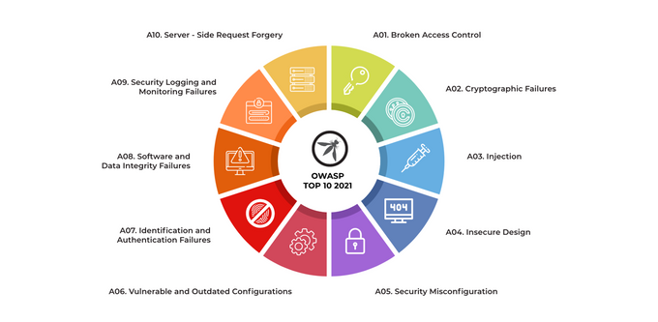
What is OWASP Top 10?
The OWASP Top 10 is published every four years and is based on data from the previous four years. The list is not structured around how severe each vulnerability is. Instead, it compiles vulnerabilities based on how common they are so you can prevent the most common risks to sensitive data exposure.
OWASP Top Ten is a starting point for organizations to improve their software security.

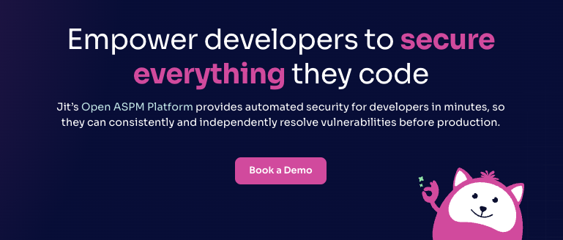
Open ASPM Platform
App + cloud security that developers love
Read reviews
Learn More
Coverage
SAST, SCA, secrets detection, IaC scanning, DAST, CSPM, and other product security controls

Easy for developers to adopt
Automated scanning within dev environments

Automated prioritization
Automatically surface exploitable vulnerabilities in production

Easy onboarding
Integrate Jit with your Source Code Manager to enable one-click activation for all tools
Brief overview
Jit empowers developers to consistently and independently resolve vulnerabilities before production with automated scanning in their environment.
Rather than requiring developers to scroll through long vulnerability backlogs in different UIs, Jit provides immediate feedback on the security of every code change within GitHub, GitLab, or VsCode.
As a result, Jit makes it exceptionally easy for developers to adopt regular security testing within their environment.
Key features
- Unified SAST, SCA, secrets detection, IaC scanning, CSPM, DAST, and other product security controls
- Unified execution and UX for all security tools
- Fast and automated scanning within GitHub, GitLab, or VsCode
- Jit’s Context Engine determines whether a vulnerability is actually exploitable in production to prevent alert fatigue and long backlogs of irrelevant vulnerabilities
- Unified monitoring and reporting
Pros and cons
Easy for developers to adopt
Unifies all tools
Automated vulnerability prioritization based on runtime context
Fast onboarding across all repos
Not open source
OWASP Top Ten 2017 vs. 2021
Cyber vulnerabilities continuously change, and OWASP Top 10 list adapts to reflect that. Since the last list was released in 2017, quite a lot has been modified.
Three new categories were added:
- Insecure Design
- Software and Data Integrity Failures
- Server-Side Request Forgery (SSRF)
Some of the vulnerabilities published on OWASP Top 10 2017 have also changed name or scope to adapt to market changes:
Insufficient Logging and Monitoring is now called Security Logging and Monitoring Failures.
Some vulnerabilities have remained unaltered, but they have moved spots:
Broken Access Control is now considered the most common vulnerability, taking the number one spot.
Below we will look at the latest OWASP Top Ten list and each vulnerability in detail.
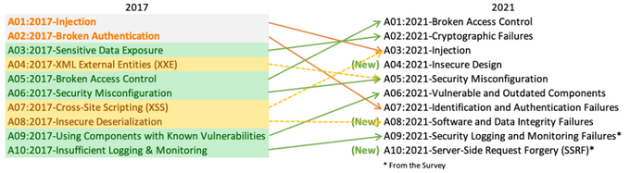
Breaking down the OWASP Top 10 Vulnerabilities
As the world of web application security continues to evolve, the OWASP Top 10 threats provides a robust framework for developers and security professionals to identify and mitigate the most common attacks.
Here are the OWASP Top 10 vulnerabilities and tips on how to prevent them.
1. Broken Access Control
In a nutshell, broken access control means that an attacker can access resources or data they should not have access to. This can be done in many ways, but typically by exploiting flaws in how the system controls access to those resources. 61% of all breaches involve broken access control.
There are many ways to exploit broken access control, but the result is always the same: the attacker gains access to data or resources they should not have access to.
Preventing Broken Access Control
Access control is a security measure that protects resources from unauthorized access. There are many different ways to achieve this, but one common method is to use a whitelist.
A whitelist is a list of authorized users that are allowed to access a particular resource.
This list can be maintained manually or generated automatically based on user credentials.
A whitelist can be implemented by creating a list of approved websites or IP addresses and then comparing any incoming requests against that list. If the request is not on the list, it will be blocked.
One way to create a whitelist on AWS is through an IAM policy that allows access only to the specific IP addresses or CIDR ranges that you wish to allow access to, and configuring your security groups to only allow traffic from those IP addresses or CIDR ranges.
2. Cryptographic Failures
Insecure communications constitute a significant problem on the internet today.
Unencrypted or weakly encrypted communications can be intercepted and read by anyone with the right tools. This can lead to the disclosure of sensitive information, like passwords, financial data, and personal information.
In 2023 alone, there were well over 8 billion records breached, and the average cost of a data breach sits at around $4.54 million.
Preventing Cryptographic Failures
When data is sent over the internet using HTTPS, it is encrypted using a cryptographic algorithm, which makes it difficult for attackers to read or tamper with the data.
To implement HTTPS in Nginx, you will need to purchase and install an SSL certificate. Once you have your certificate, you will need to edit your Nginx configuration file to enable SSL.
The specific directives you need to edit will depend on your configuration, but they will typically be something like:
ssl_certificate /path/to/your/certificate.crt;
ssl_certificate_key /path/to/your/certificate.key;
After you have edited your configuration file, you will need to restart Nginx for the changes to take effect.
3. Injections
Injections are one of the most common web application vulnerabilities. They occur when user input is not properly sanitized before being used in an SQL query or other operation.
This allows attackers to execute their SQL code, potentially resulting in data loss or corruption. In some cases, it may also allow attackers to access sensitive information such as passwords or credit card numbers.
There are many different types of SQL injection attacks, but they all exploit the same basic vulnerability.
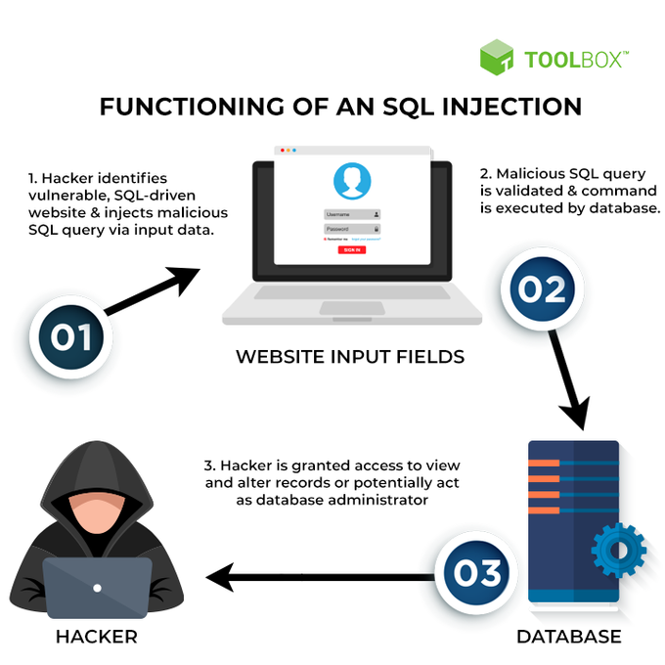
Preventing Injections
Cross-site scripting (XSS) attacks occur when a malicious user injects code into a web page that is then executed by other users who visit the page. This can lead to the theft of sensitive information or the execution of unwanted code on the user's machine.
Sanitizing user input is important because it helps to prevent XSS attacks.
There are a few ways to sanitize user input in React, Vue, and Angular:
- In React: Use the DOMPurify library to sanitize user input. DOMPurify will parse and sanitize HTML, making it safe to render on your page.
- In Vue: Use the v-html directive to render HTML safely. The v-html directive will ensure that any HTML code passed to it is properly encoded and escaped, making it safe to render.
- In Angular: Use the DomSanitizer service to sanitize user input. DomSanitizer will help you prevent XSS attacks by sanitizing untrusted values that are passed into your application.
4. Insecure Design
Insecure design refers to security flaws introduced during software development's design phase. Design flaws can lead to a wide range of security vulnerabilities, including:
- Injection flaws: User input is not properly sanitized before it's used by the application. The malicious code is injected and then executed by the application, leading to data loss or corruption, Denial of Service (DoS) attacks, or arbitrary code execution.
- ‍Cross-site scripting (XSS) flaws: XSS flaws occur when user input is not correctly escaped or sanitized before it's displayed by the application. Attackers inject malicious code executed by unsuspecting users who visit the compromised page.
- ‍Broken authentication and session management: These occur when authentication and session management mechanisms are not correctly implemented. Attackers can access sensitive data, hijack user sessions, or perform other malicious actions.
- ‍Insecure communications: Insecure communications refer to the use of insecure protocols or encryption algorithms that allow attackers to eavesdrop on communications or tamper with data.
Preventing Insecure Design
One way to prevent cross-site scripting is to implement a content security policy (CSP).
A CSP is a list of directives that specify what resources are allowed to be loaded on a page.
These directives can be used to restrict the sources of content that can be loaded on a page and can be implemented in the <meta> tag of an HTML document or in the HTTP headers of a server.
Here is an example of a content security policy implemented in the <meta> tag of an HTML document:
<meta http-equiv="Content-Security-Policy" content="default-src 'self'; img-src https://example.com;">
This policy allows content from the same origin (self) to be loaded by default and will allow images from https://example.com to be loaded.
Here is an example of a content security policy implemented in the HTTP headers of a server:
Content-Security-Policy: default-src 'self'; img-src https://example.com;
This policy will have the same effect as the policy above.
5. Security Misconfigurations
Security misconfiguration is a broad category of issues that can arise when an application or server is not configured correctly.
Incorrectly configured systems are more vulnerable to attacks, allow unauthorized access to sensitive data, and provide misleading information to users.
All too often, systems are not adequately configured because administrators don't have the time or knowledge to do so correctly, which leaves systems open to attack. Sometimes, administrators are aware of how important proper configuration is, but corporate policies and other restrictions may prevent them from ensuring it.
Common security misconfiguration issues include:
- Leaving the default administrator account active and using weak passwords
- Not disabling directory listing
- Not requiring SSL/TLS for sensitive communications
- Not properly restricting access to files and directories
- Not properly securing database passwords and other sensitive data
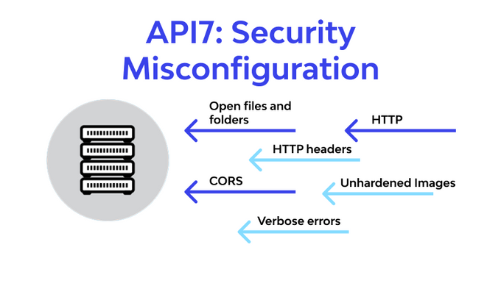
Preventing Security Misconfigurations
One way to make SSL/TLS compulsory is to use a web server that requires it for all connections. For example, the Apache web server can be configured to require SSL/TLS by adding the following directive to the server configuration:
SSLRequireSSL
Another way to make SSL/TLS compulsory is to use a load balancer or proxy server that supports SSL/TLS and requires it for all connections.
For example, the Nginx web server can be configured as a proxy server to require SSL/TLS by adding the following directive to the server configuration:
proxy_ssl_session_reuse on;
proxy_ssl_protocols TLSv1 TLSv1.1 TLSv1.2;
proxy_ssl_ciphers HIGH:!aNULL:!MD5;
6. Vulnerable and Outdated Components
Vulnerable and outdated components are often the Achilles' heel of an organization's security posture. A vulnerable component is one with known security flaws that can be exploited to gain unauthorized access or cause other harm.
An outdated component is one for which security patches or updates are no longer available from the vendor, making it more susceptible to attack.
Preventing Vulnerable and Outdated Components
Preventing vulnerable and outdated components is not complicated—which is all the more reason to do it.
The best ways to prevent vulnerable and outdated components include:
- Removing all unused components
- Monitoring components for vulnerabilities
- Limiting access to components
- Regularly auditing components
» Learn how to automate OWASP ZAP for easier monitoring.
7. Identification and Authentication Failures
An identification and authentication failure occurs when a system fails to correctly identify and/or authenticate a user.
This can happen for various reasons, but typically it is due to:
- Weak or easy-to-guess passwords
- Lack of strong password policies
- Lack of two-factor authentication.
Organizations are vulnerable to approximately $1.76 million in business costs when a Zero Trust authentication system is not implemented.
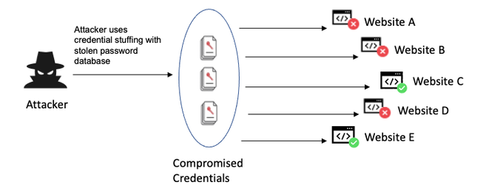
Preventing Identification and Authentication Failures
There are many ways to implement 2-factor authentication (2FA) with AWS. One way to do it is to use AWS Identity and Access Management (IAM) with multi-factor authentication (MFA).
IAM is a web service that helps you securely control access to AWS resources.
MFA adds an extra layer of security by requiring a second factor, such as a code from a hardware device or a mobile app, in addition to your username and password.
To set up an MFA, you first need to create an IAM user and then attach an MFA device to that user. You can use any type of MFA device that is compatible with AWS, such as a hardware device or virtual device.
Once you have an IAM user with an MFA device attached, you can enable MFA for that user. To do this, you need to create an IAM policy that requires MFA. You can then attach this policy to the IAM user.
Here is an example of an IAM policy that requires MFA:
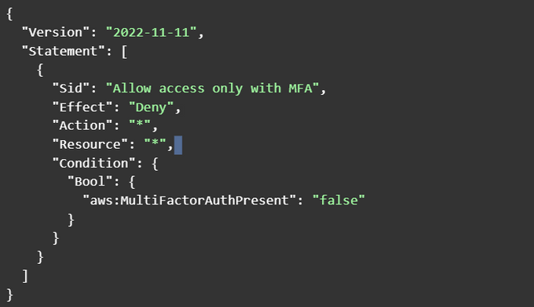
This policy denies all access to all resources unless the user has an MFA device attached.
After you have created this policy, you must attach it to the IAM user. You can do this via the AWS Management Console or the AWS Command Line Interface (CLI).
Once the policy is attached, the user must use MFA when accessing AWS resources.
8. Software and Data Integrity Failures
Data integrity failures are a type of security vulnerability that can occur when data is modified or destroyed without authorization. This can happen either through malicious attacks or accidental mistakes.
Software and data integrity failures can have serious consequences, such as financial losses or the exposure of confidential information.
There are several ways to protect data from integrity failures.
One is to use cryptographic methods, such as digital signatures or hashes, to verify that data has not been changed.
Another is to store data in multiple locations so that if one copy is destroyed, others can be used to reconstruct it. Back up data regularly so that a copy is always available in case of an integrity failure.
Preventing Software and Data Integrity Failures
In order to prevent software and data integrity failures, make sure to:
- Regularly back up data and software
- Keep software and data secure
- Ensure data and software integrity
- Monitor systems for changes
- Detect and respond to changes quickly
9. Security Logging and Monitoring Failures
In the world of information security, logging and monitoring failures are all too common.
Log data integrity failures can lead to data loss or corruption while monitoring failures allow attackers to operate undetected.
Security logging is tracking events that occur on a computer or network. This data can be used to identify attacks, monitor system activity, and track user behavior. However, if this data is not secured correctly, attackers can compromise it.
Failures can have severe consequences for an organization. The average life cycle of a breach is 200 days, which, on average, translates to $4.45 million in costs.
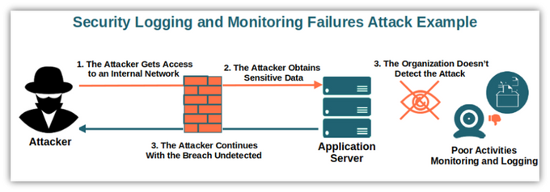
Preventing Security Logging and Monitoring Failures
To prevent security logging and monitoring failures, a company can:
- Ensure that all logging and monitoring tools are correctly configured and tested
- Establish clear and concise logging and monitoring policies and procedures
- Educate all staff on the proper handling of sensitive information
- Regularly review logs and monitor activity for unusual or suspicious activity
- Investigate and resolve any issues identified through logging and monitoring
10. Server-Side Request Forgery (SSRF)
Server-side request forgery (SSRF) is an attack in which the attacker tricks a server into requesting on their behalf.
SSRF can be performed by specifying a malicious URL in a parameter or embedding an HTTP request in an XML document. If the server does not properly validate the request, it will send the request to the attacker-specified URL.
SSRF can be used to attack internal systems that are generally not accessible from the outside. For example, an attacker could use SSRF to access a server's internal network or read sensitive files on the server.
Preventing Server-Side Request Forgery (SSRF)
Preventing a server-side request forgery includes several steps:
- Ensure that user input is validated and sanitized
- Restrict user access to only the resources that they need
- Implement a whitelist approach to input validation
- Monitor server access logs for suspicious activity
- Keep all server software up to date with the latest security patches
Protect Your Applications Against OWASP Top 10 Threats
Malicious users never rest, and neither should your security postures.
To guard against attacks exploiting OWASP Top 10 vulnerabilities, try using tools like OWASP ZAP to run dynamic scans against your applications to look for holes.
Or, to quickly implement ZAP alongside other application security tools like SAST, SCA, secrets detection, and others, consider Jit to protect your applications against OWASP Top 10 vulnerabilities while causing no friction to your software engineering team.

OWASP Top 10: A Detailed Overview with Examples | by Linux Learners | Medium
OWASP Top 10: A Detailed Overview with Examples



Linux Learners
Follow
4 min read
·
Jan 20, 2025
4
1

The OWASP Top 10 is a list of the most critical security vulnerabilities, curated by the Open Web Application Security Project (OWASP). Understanding these vulnerabilities is essential for developers, cybersecurity professionals, and anyone interested in secure application development. Let’s dive into each vulnerability with detailed explanations and examples.
1. Broken Access Control
Definition: Occurs when users can access resources or perform actions beyond their intended permissions.
Example:
Suppose a banking app allows users to view their transactions at /account/{id}. If an attacker changes the URL from /account/123 to /account/456, they might view another user’s account without authorization.
Prevention:
- Implement role-based access control (RBAC).
- Verify user permissions on both client and server sides.
- Use secure frameworks to handle access control.
2. Cryptographic Failures
Definition: Arises when sensitive data (like passwords or credit card information) isn’t properly protected using encryption.
Example:
A website stores user passwords in plain text. If the database is breached, all passwords are easily exposed. Using outdated algorithms like MD5 or SHA-1 can also make data vulnerable to brute force attacks.
Prevention:
- Use strong, modern encryption algorithms like AES-256.
- Always encrypt data in transit using TLS (HTTPS).
- Store passwords using strong hashing algorithms like bcrypt or Argon2.
3. Injection
Definition: Occurs when untrusted input is executed as part of a command or query, leading to unintended actions.
Example:
SQL Injection: A login form executes the query:
SELECT * FROM users WHERE username = 'user' AND password = 'pass';
An attacker inputs:
username: ' OR 1=1 --
password: (empty)
The resulting query becomes:
SELECT * FROM users WHERE username = '' OR 1=1 -- ' AND password = '';
This always returns true, giving the attacker unauthorized access.
Prevention:
- Use parameterized queries or ORM tools like SQLAlchemy or Entity Framework.
- Sanitize and validate all user inputs.
4. Insecure Design
Definition: Refers to vulnerabilities introduced by flawed application design.
Example:
A shopping website allows unlimited password reset attempts without verifying if the request came from the user, leading to abuse.
Prevention:
- Implement secure-by-design principles during development.
- Use threat modeling and regular code reviews.
- Apply rate limiting to sensitive endpoints.
5. Security Misconfiguration
Definition: Happens when security settings are improperly configured, leaving systems exposed.
Example:
- A web server has directory listing enabled, exposing sensitive files like /config or /backup.
- Default admin credentials (e.g., admin:admin) remain unchanged.
Prevention:
- Regularly audit and harden configurations.
- Disable unnecessary features like directory listing or verbose error messages.
- Rotate and enforce strong credentials.
6. Vulnerable and Outdated Components
Definition: Using outdated software components with known vulnerabilities.

Example:
The Equifax data breach (2017) occurred because the company failed to patch a known vulnerability in Apache Struts (CVE-2017–5638).
Prevention:
- Regularly update all dependencies and software components.
- Monitor vulnerability databases like CVE or NVD.
- Use tools like Dependabot or Snyk to identify vulnerabilities in dependencies.
7. Identification and Authentication Failures
Definition: Occurs when authentication mechanisms are weak, allowing attackers to impersonate users.
Example:
- A session ID is predictable, so an attacker can hijack sessions.
- Multi-factor authentication (MFA) is absent, making brute force or credential stuffing easier.
Prevention:
- Use robust authentication mechanisms like MFA.
- Implement strong session management with secure cookies (HTTPOnly and Secure flags).
- Prevent session fixation attacks by regenerating session IDs after login.
8. Software and Data Integrity Failures
Definition: Relates to the lack of validation on software updates or critical data.
Example:
A software update is downloaded over HTTP instead of HTTPS. An attacker intercepts and modifies the update to include malware.
Prevention:
- Use signed updates and verify the integrity before applying them.
- Secure CI/CD pipelines to prevent unauthorized changes.
9. Security Logging and Monitoring Failures
Definition: Occurs when security events (e.g., login attempts, error messages) aren’t logged or monitored.
Example:
- A brute force attack on login pages goes unnoticed because no failed login attempts are logged.
- Anomalous traffic is not flagged, leading to undetected data breaches.
Prevention:
- Implement logging for all critical activities (e.g., login attempts, data access).
- Use SIEM tools like Splunk or ELK Stack for real-time monitoring.
- Regularly review logs for suspicious activity.
10. Server-Side Request Forgery (SSRF)
Definition: Happens when an attacker tricks a server into sending requests to unintended locations.
Example:
A file upload feature accepts a URL input to fetch the file. The attacker provides http://localhost/admin, which the server fetches, exposing internal admin data.
Prevention:
- Validate and sanitize user-supplied URLs.
- Restrict outbound requests from the server to only necessary domains.
- Implement network segmentation to limit access to internal resources.
Conclusion
The OWASP Top 10 is a vital resource for understanding common security vulnerabilities and their mitigation strategies. By addressing these vulnerabilities during the development process, we can build more secure and resilient applications. For cybersecurity professionals, keeping up with the OWASP Top 10 is an essential step toward safeguarding systems and data.

